STEP 1:
Campaign Summary – Social Connect
1. Campaign Goals and Initial Strategy
The goal of the Social Connect campaign was to increase user engagement, gain new followers, and promote the app as a platform for connecting people. The strategy included regular posting on Instagram and Facebook using attractive graphics, short videos, engaging captions, and relevant hashtags.

2. Adjustments During the Campaign
Based on feedback and performance data, posting times were improved, captions were made more engaging, and better hashtags were used. More video and interactive content (polls, Q&A) was added to increase engagement.

3. Key Performance Metrics
Metric | Result
Impressions | 6,500
CTR | 4.5%
Engagement | 420 interactions
Followers | +180

4. Performance Analysis
The campaign successfully increased reach and engagement. Video and interactive content performed best. CTR was moderate and can be improved with stronger call-to-action strategies.

STEP 2:
Content Portfolio – Social Connect
Introduction
This portfolio presents all the content created during the Social Connect campaign, including graphics, videos, ad creatives, and engagement posts.

1. Social Media Posts (Graphics)
These posts were designed using attractive visuals and engaging captions.

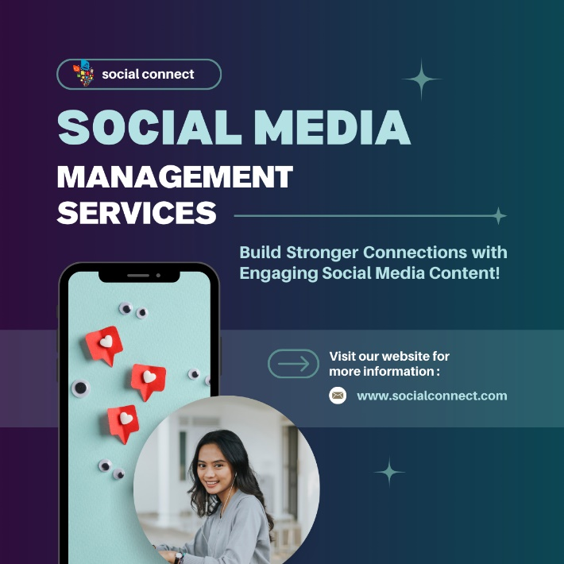

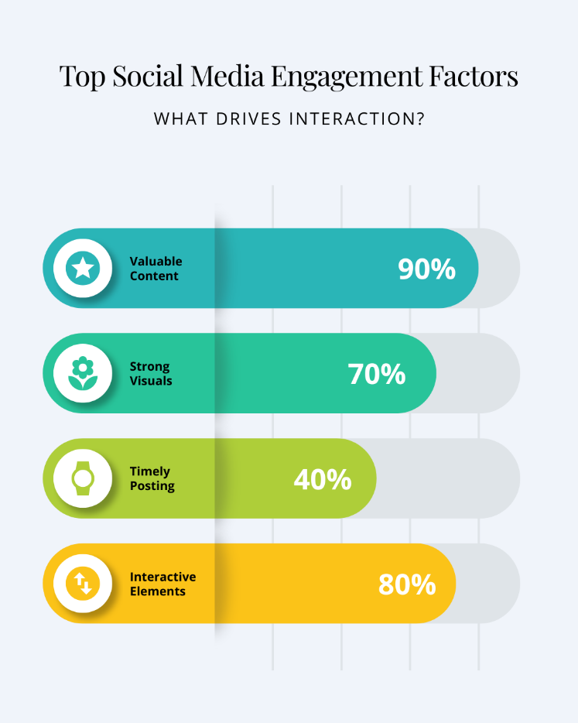



2. Video Content
Short videos and reels were created to increase engagement and reach.

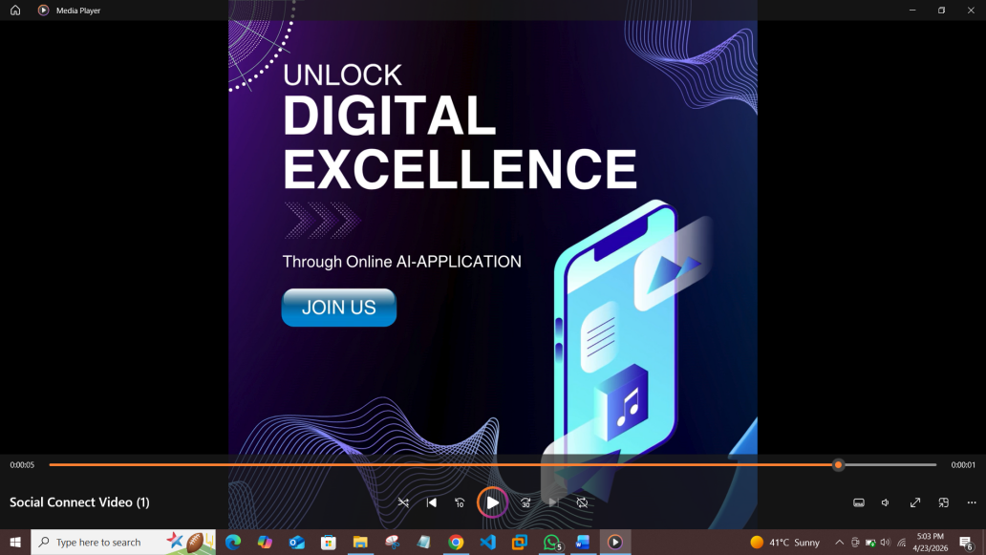
Link:
https://drive.google.com/file/d/1v_RnKH-d86d8Jpy2NpU4yz_zpFFOzu40/view?usp=sharing

3. Ad Creatives
Promotional posts with call-to-action like “Join Now” were used to attract users.
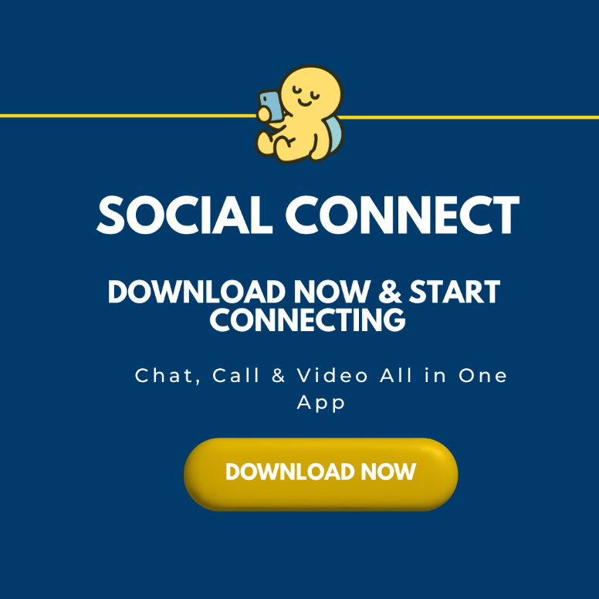
4. Engagement Content
Polls, Q&A, and interactive posts were used to connect with the audience.
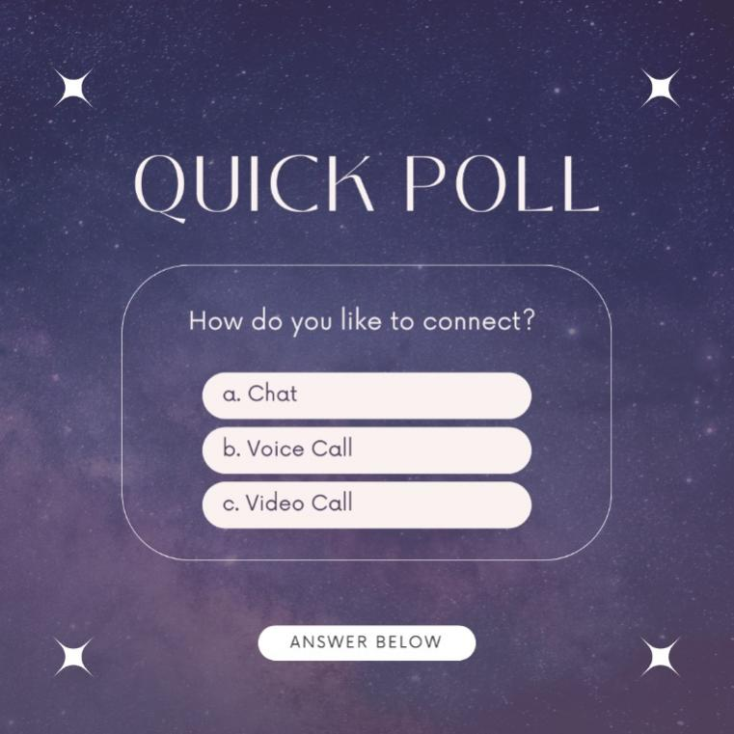
Conclusion
The content successfully improved engagement and helped promote the app effectively.

